LABORATORY # 07

Characteristics of FETs

Purpose
Introduce the concept of Field Effect Transistors (FET), with the added component of a Gate to a BJT. Understanding the configuration and states of FETs will be a critical part of knowing how MOSFETs work. Both NPN and PNP constructions will be considered to get an in depth understanding of transistors. Constants and variables relating to FETs will be discussed and utilized in the Procedure to confirm a full understanding of the material.

Theoretical Background
Construction - A FET is constructed with four parts: a gate region, a body region, a drain region and a source region. The body is also at times referred to as the channel if voltage in the gate is field affecting through a capacitance to make the FET design active allowing current to flow through the body. For an N-channel FET the body is a P-type material, the drain and source is both N-type materials, with a drain that has more electrons than the source. For a P-channel FET the body is a N-type material, the drain and source are both P-type material, with a drain that has more holes than the source. The material used to make the gate has no effect for ideal operation because the gate should have no junctions, it provides the electric field (could be seen as a small capacitance on the FET).
Operation - The current is meant to flow through the body/channel region if the transistor is in “Linear Operating” mode. To get the FET into “Linear Operating” mode one must place a charge on the gate. For this laboratory we will be using Junction Field Effect Transistor (JFET). So the result of placing a charge on the gate of such a device alters the required potential between source and drain to make a channel through the body. The voltage needed on the gate to allow for the flow through the drain is known as threshold voltage. This gate voltage can be kept close to the threshold voltage relative to source-drain voltage in order to make the JFET act as a current controlling device, keeping the current the same regardless of drain to source voltage.

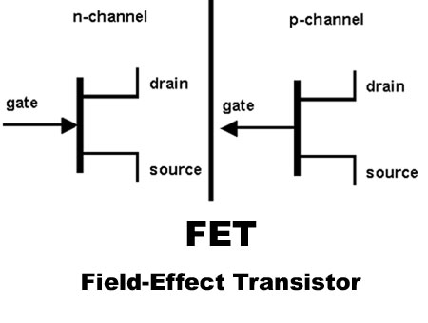

Figure 9.1 Symbolic representation

Theoretical Analysis
Variables and Operating States - Similar to BJTs keep in mind that diagrams, formulas and charts relating to FETs will use “D” to represent the Drain, “S” to represent the Source, “G” to represent the Gate, and “B” to represent the Body. The extra Gate region creates more possible variables and constants to properly calculate the transistor inputs and outputs than those used for BJTs. The three operating states are used to clarify under what conditions particular formulas are used. The voltage threshold (Vth) is used to represent the value of the voltage required between the gate and source (Vgs) in order to allow current to pass through the body.

Output characteristic V-I curves of a typical junction FET:
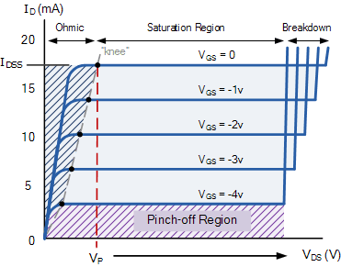
Figure 9.2 Drain Characteristics
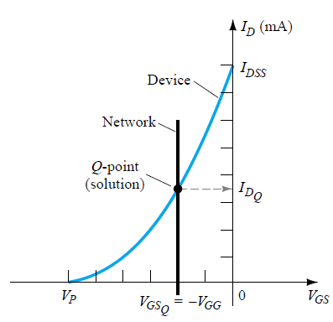
Figure 9.3 Transfer Characteristics

Circuit
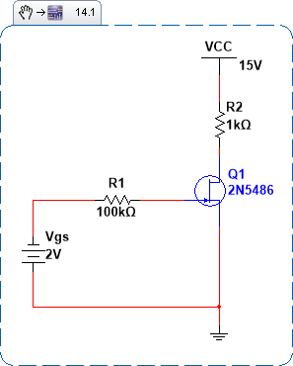
Figure 9.4 JFET (2N5486) circuit
Lab Results
Table 9.1 – Experimental.
Drain Characteristic (NPN 2N5486)
Vcc = Vds | Vgs = 0 | Vgs = -1 | Vgs = -2 | Vgs = -3 | Vgs = -4
 | Id | Id | Id | Id | Id
0 | -0.00mA | -0.00mA | -0.00 | -0.00 | -0.001
4 | 3.67mA | 3.499 | 3.26 | 2.36 | 0.303
8 | 7.25mA | 6.897 | 5.92 | 2.81 | 0.378
12 | 10.75mA | 9.837 | 6.82 | 2.98 | 0.427
16 | 13.94mA | 11.24 | 7.02 | 3.09 | 0.467
20 | 16.43mA | 11.55 | 7.03 | 3.15 | 0.503
24 | 16.67mA | 11.28 | 7.06 | 3.20 | 0.541

Table 9.2 - Experimental

Vds = 15V
Vgs | 0 | -1 | -2 | -3 | -4 | -5
Id | 13.17mA | 11.03 | 7.01 | 3.09 | 0.47 | 0.00

Part (a)
- Implement the circuit shown in Fig 9.4 in Multisim (use 2N5486).
- Complete Table 9.1 and Table 9.2 using Multisim results:
- Use DC Sweep in Simulation
- Set Source 1 to Vcc with range from 0 to 24 and increment of 4.
- Set Source 2 to Vgs with range from 0 to 4 and increment of 1.
- Select Output as current of drain (IR2). Fill Table 9.1
- Set Vcc as constant 15V. Set Source 1 to Vgs with range from 0 to 5 with increment of 1. Fill Table 9.2.
- Draw the drain and transfer characteristics as per your recorded results in Table 9.1 and Table 9.2.
- What is your pinch off voltage?

Part (b)
- Repeat part (a) using experimental results (use 2N5486). Fill Table 9.1 and 9.2 with lab results. Compare the lab results with your simulation and analyze the difference in Conclusion section in your report.
- What is your pinch off voltage? 4.8V
Reference: Electronic Devices and Circuit Theory, 7th Ed. by Robert Boylestad and Louis Nashelsky.
Table 9.1 – Simulation.
Drain Characteristic (NPN 2N5486)
Vcc = Vds | Vgs = 0 | Vgs = -1 | Vgs = -2 | Vgs = -3 | Vgs = -4
 | Id | Id | Id | Id | Id
0 | -0.00mA | -0.00mA | -0.00 | -0.00 | -0.001
4 | 3.39mA | 3.19 | 2.65 | 0.63 | 0.16
8 | 6.70mA | 6.06 | 3.05 | 0.67 | 0.28
12 | 9.83mA | 7.15 | 3.25 | 0.72 | 0.40
16 | 12.49mA | 7.59 | 3.45 | 0.76 | 0.52
20 | 13.32mA | 8.02 | 3.64 | 0.81 | 0.64
24 | 14.03mA | 8.45 | 3.84 | 0.85 | 0.76

Table 9.2

Vds = 15V
Vgs | 0 | -1 | -2 | -3 | -4 | -5
Id | 13.17mA | 11.03 | 7.01 | 3.09 | 0.47 | 0.00

